**Effectiveness in Advertising for Crowdfunding Campaigns**

Jacob Haight, Tyler Jolly, Charisse Spencer

**Introduction**

Crowdfunding is a common technique of fundraising for various projects in all sorts of industries. Kickstarter in particular has seen tremendous platform usage and provides impressive self-reported statistics [12]. As a relatively new and significant platform for raising funds, creating an audience, and launching products, marketing strategies for crowdfunding campaigns become important for current and potential producers to consider and explore. Using automated simulations to determine general efficiency of advertising in crowdfunded platforms, we can better understand the underlying fundamentals of how advertising reaches new customers and affects the market as a whole [7]. From there, advertising may be empirically investigated, applied, and improved. Incorporating economic principles such as individual rationality [16] in a model can simplify behavior without compromising too much realism [1].

In this paper, we address previous work, propose an economically sound computerized model to explore the effectiveness of advertising for crowdfunding campaigns, present our preliminary results, and discuss next steps in this area of research.

**Previous Work**

Dynamic crowdfunding models have been created to test specific properties that occur in the crowdfunding market. By analyzing large quantities of data about crowdfunding competitiveness, researchers were able to statistically model the effect competition has with an accuracy 32-45% that of previous models [11].

Another model has tested the efficiency of crowdfunding models from the perspective of the firms and also of greater society. The research found the equilibriums of contributions for differently valued and priced goods [3].

Another analysis of what makes a measurably good crowdfunding campaign focused on the specific aspects of what to market and how, giving a guide on how to run a crowdfunding campaign [14].

A step away from crowdfunding and into marketing and advertising, work has been done that demonstrates the effect of advertisement and reviews. It showed that the higher the trust given by the reviews, the less is spent on advertising [9].

All of these previous models studied specific aspects of crowdfunding. Our work will explore a new direction of the Consumer and Producer relation through advertising with the presence of an echo chamber, a known social phenomenon [2].

**Model**

Our proposed model consists of a simulation that lasts a set amount of timesteps wherein a graph of Consumers and Producers interact in various ways.

* Simulation steps

We suggest the following basic steps and order thereof to run in this model:

func runTimeStep()

{

consumerBuy()

producerAdvertise()

consumerUpdate()

}

First, Consumers calculate a contribution value for each Producer and buy if it is a positive amount. Then, Producers determine how much to spend on advertising and pick a strategy. Lastly, the graph will update Consumer-Consumer influence.

While configurable, for most runs, the simulation lasted 30 timesteps, figuring a timestep is equivalent to 1 day. Empirical research shows that over 30 days, a vast majority of projects that will ultimately succeed will have met their fundraising goal by this point [13].

* Social network graph

All Consumers are connected to all other Consumers and producers with a weight of 0 initially. Weights for each edge are then randomly selected from a uniform distribution of the respective range (i.e. Consumer-Consumer or Consumer-Producer). Consumer nodes are connected to other Consumer nodes with a binary awareness relationship. While this is a simplification from reality where people generally have higher and lower regards of friends or connections [8], most social network platforms have only a binary option (following/not following, friended/not friended, etc.).

To simulate the echo chamber effect [2], Consumers influence their respective neighbors. More influential Consumers are those that have many “1” connections and have extreme preferences. A Consumer’s influence on another Consumer can be described by *sa*/2, where *s* is a set atomic step value (e.g. 0.03) and *a* is the average preference value for the same genre between the two Consumers. The step value moderates the degree to which Consumers affect other’s preferences.

* Consumers

Consumer nodes are connected to other Consumer nodes as well as Producer nodes. The weight of the edge connecting them is representative of awareness in both cases. For Consumer-Consumer connections, it is a binary awareness ({0, 1}) of each other and for Consumer-Producer connections, weights are float values ({x : x ∈ [0, 1]}) of the Consumer’s awareness of the Producer (or, more accurately, the campaign it represents).

Consumers each have a set of genre preferences which can be modified through the influence of neighbors and through certain advertising strategies. Preferences are defined for each Consumer, i.e., there are no unknown or unordered preferences. Preference values were randomly selected from a uniform distribution on range [-1, 1], where negative values are a dislike of the genre, positive values are a preference of the genre, and 0 is indifference.

Consumers each have a risk tolerance randomly selected from a uniform distribution on range [0,1]. A low risk tolerance represents skepticism about the return value of an investment [4]. This affects the amount of the full speculative value of a Producer that a Consumer would contribute. A risk-neutral Consumer will always contribute the full speculative value for a given Producer. Risk-seeking Consumers were not considered for this model.

The speculative value for a given Producer is calculated with the following equation: (*pa*(*g*+1))/*r*, where *g* is the percentage of the Producer’s funding goal met (current funding of the Producer/campaign goal), *r* is the risk tolerance of the Consumer, *p* is the Consumer’s preference for the genre of the Producer, and *a* is the Consumer’s awareness of the Producer. Awareness in this context is similar to incomplete information risk. The more knowledgeable a Consumer is about a Producer, the more sure it is about its speculative value of the Producer’s end product. Consumers only recontribute to a Producer if its speculative value has increased at all. Consumers recontribute only the marginal increase to their speculative value.

Consumers are given a set amount of initial funds (i.e. disposable income). Given the simulation time-frame, additional funds are not dispersed. We assume Consumers use a monthly budget and remaining funds may roll over to the next period. This limits indifferent behavior wherein if funds expire, Consumers are indifferent between investing in any project regardless of speculative value (including negative evaluations) and keeping the now expired funds through the last time step of the simulation. Initial funds are randomly selected from a uniform distribution on range [y/2, y], where y is a configurable parameter.

* Producers

Producer nodes are connected only to Consumer nodes in the graph. Producers are initialized with a campaign goal, a genre, and an advertising strategy predisposition. Each Producer aims to reach the funding goal for their project and can advertise to directly manipulate awareness or preference in the Consumer market.

Producers are each given a goal at initialization and it is a value randomly selected from a uniform distribution in range [x/2, x], where x is a configurable parameter.

The strategy predisposition is a threshold value randomly selected from a uniform distribution with range [0,1] where a high strategy value means they are predisposed to use strategy A more often than not, a low value means they are predisposed to use strategy B more often than not, and 0.5 means they are equally likely to use either strategy. The strategy selection value to compare against is randomly selected from a uniform distribution on the same range and is selected anew each simulation timestep.

Producers prorate ad expenditure against how far from the goal they are. The closer to the goal a Producer is, the less it will spend on advertising. It is also weighted by the historical average of the market’s preference of the Producer’s same genre at large. A higher market preference will result in a larger spend amount as advertising is more likely to be successful in an environment where the genre is positively regarded [10].

* Marketing Strategies

Producers select between the following strategies using the previously mentioned logic.

*Strategy A (Blanket)*: This strategy affects awareness for the specific Producer which employs this strategy. In practice, blanket strategies may include website ad slots, social media interaction, and other generally non-targeted advertisements [6]. Consumer edge weights are updated with the equation tanh(log(*a*)(*p*+1)*w*), where *a* is the ad expenditure of the Producer for this round of advertising, *p* is the current preference of the Consumer for the Producer’s genre, and *w* is the current edge weight, or 0 if it does not produce a positive weight.

*Strategy B (Influencers)*: This strategy mimics advertising through selecting a few influencers to advertise a product and raise preference for the genre as a whole [4]. Producers affect consumer preferences with the equation tanh(log(*a*)*p*), where *a* and *p* represent the same variables as Strategy A.

For both strategies, advertising is applied to all consumers though it may not have any effect on (an) individual(s). For example, consumers who are unaware of a Producer which is using Strategy A and has a negative outlook on the Producer’s genre will remain unaware, thus their speculative value is essentially non-existent.

**Results**

With the model that we created, we tried three different population ratios between Consumers and Producers. The maximum goal amount for Producers and the amount of starting money for Consumers were adjusted in addition to account for the population changes. The reason for this is because it is harder to get more money than the Consumer population has in it, so those values had to be adjusted.

For all runs, we had 6 genre types and a 40% chance for each Consumer-Consumer connection to exist (i.e. be nonzero). Not every genre was guaranteed to be produced (i.e. have at least one Producer of that genre).

|  | 100 Consumers, 10 Producers. Max goal amount 200 | 1000 Consumers, 50 Producers. Max Goal amount 2000 | 2000 Consumers, 20 Producers. Max Goal amount 200 |
| --- | --- | --- | --- |
| Goal Completed | 10 % | 2% | 5% |
| Goal Completed Time | 19 time steps | 4 time steps | 1 time step |
| Strategy | 66% A, 34% B | 56% A, 43% B | 48% A, 52% B |
| Goal Amount | 66.8% of Max goal | 57.38% of max goal | 74.6% of max goal |
| Money Made | 167.7% of Max goal | 71.78% of max goal | 47.01% of max goal |
| Money Spent | 4.09% of Max goal | 3.69% of Max goal | 0% of Max goal |

*Figure 1: Averages of the Producers that completed the goal*

Figure 1 shows the collated averaged data from at least 10 runs of each column with only the Producers that completed their goal. The amount earned on average is normalized with the max amount of the goal to create a better comparison. As the total population increases, fewer Producers complete their goal.

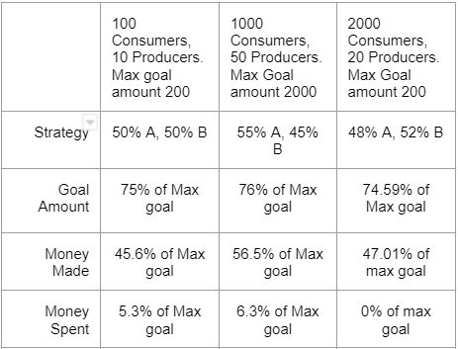  *Figure 2: Average values of the total producer population*

Figure 2 shows that between the total population of the producers and producers that completed the goal, that producers that completed the goal spend less on advertising than the producers that didn’t complete the goal.

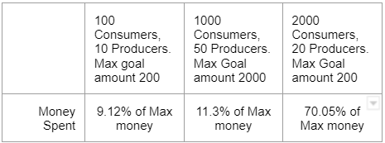*Figure 3: Average values of the money spent by total consumer population*

Figure 3 shows that with larger populations of producers and consumers that consumers will want to spend more money on average.

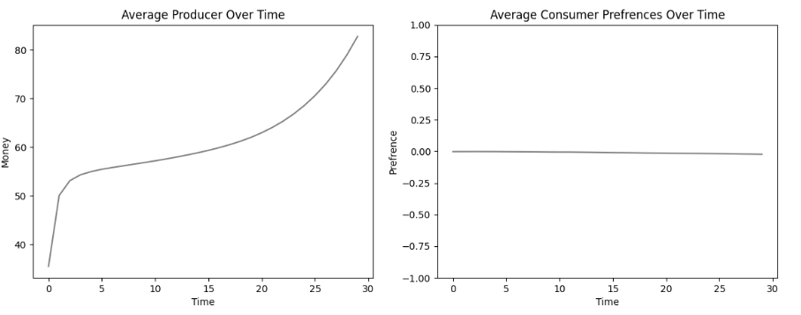*Figure 4: Average curves for the producer’s money, and consumers preferences for 100 Consumers and 10 producers*

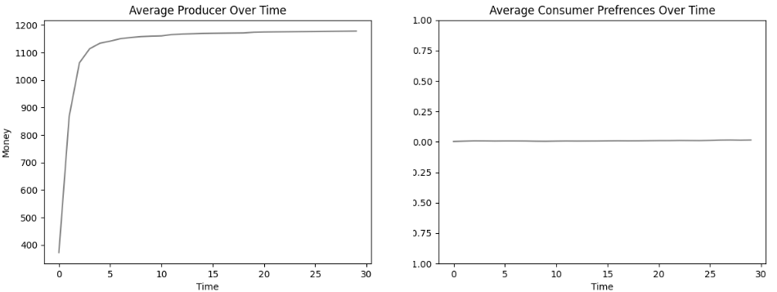*Figure 5: Average curves for the producer’s money, and consumers preferences for 1000 Consumers and 50 producers*

*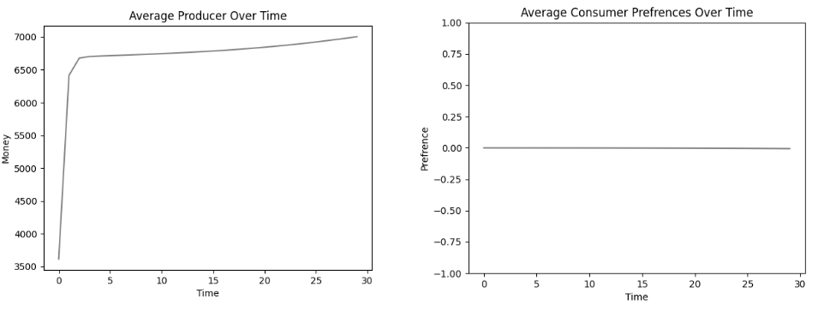Figure 6: Average curves for the producer’s money, and consumers preferences for 2000 Consumers and 20 producers*

Figures 4, 5,and 6 show the different curves that occur between the different populations. It shows that on average producers gain money quickly and then stagnate. It also shows that the average preferences of each type of simulation do not change positive or negative even with the producers getting money.

**Discussion**

* Initial Expectations

Starting with this model, the initial expectations were that of the two advertising strategies the influencer model would be the most successful/effective of the two. Crowdfunding is an interesting form of voting with your wallet and being able to accurately simulate that could be beneficial for consumers as well as for producers and helping their campaigns succeed on such platforms.

Gaining insight into these different factors that can drive a successful campaign can help enable creators to more efficiently and effectively allocate their advertising resources. Which in turn can benefit the overall development of the crowdfunding ecosystem.

* Challenges

The main challenges for this simulation are: does it really simulate reality, and if so what can be learned from the data of said simulation? Also are there more realistic marketing strategies that could be used and simulated? Trying to replicate the mechanics of crowdfunding proved challenging due to the complexities of simulating human behavior. Because of this there are some big simplifications that were made in the model specifically in how and when consumers contribute to campaigns as well as how producers choose which advertising strategy they will use. The population sizes are also a significant challenge to this model. The model as-is works well for smaller populations but doesn’t handle larger ones like one would expect of an actual crowdfunding platform.

* Realism and Usefulness

This model seems to be approaching what is realistic and one could find some useful information from the data from the simulation. The simplifications stated above do limit the realism and usefulness of the model. Expanding the complexity of the consumers and producers would provide for a more interesting and better simulation.

A main point that could help the realism of the model is simulating campaign goals with different rewards that are given to the consumers on successful completion of that specific campaign. Doing so could help simulate better the behavior of consumers contributing to campaigns as well as how much they are willing to contribute.

* Continuing Work

Many values used were either chosen somewhat arbitrarily or randomly selected. Future work could improve upon accuracy in real population modeling. Investigating smaller markets may be interesting, but would not be congruent with the concept of mass funding. Exploring market sizes closer to reality (i.e. tens or hundreds of thousands of Consumers to hundreds or thousands of Producers) may be another launching point for future work to bring crowdfunded marketing modeling closer to reality.

**Conclusion**

While the model isn’t yet fully refined, it makes great strides toward modeling and simulating crowdfunding advertising. It demonstrates individual rationality in action for both Consumers and Producers in a dynamic market. With tuning, it could scale to much larger or much smaller market sizes. Likewise, its extensibility in areas like risk tolerance in Consumers, more variable goals, a more complex genre system, etc. is a useful starting point for similar and continuing work. As crowdfunding platforms continue growing in popularity and revenue, understanding the fundamentals is a field that is unlikely to become outdated.

**References**

[1] Abate, A., Gutierrez, J., Hammond, L. et al. “Rational verification: game-theoretic verification of multi-agent systems.” Appl Intell 51, 6569–6584 (2021). <https://doi.org/10.1007/s10489-021-02658-y>.

[2] Arguedas, Robertson, et al. “Echo Chambers, Filter Bubbles, and Polarisation: a Literature Review.” Reuters Institute for the Study of Journalism, 2022, <https://reutersinstitute.politics.ox.ac.uk/echo-chambers-filter-bubbles-and-polarisation-literature-review>.

[3] Arieli, Itai, et al. “The One-Shot Crowdfunding Game.” Proceedings of the 2018 ACM Conference on Economics and Computation, 2018, <https://doi.org/10.1145/3219166.3219215>.

[4] Belanche, Casaló, et al., "Understanding influencer marketing: The role of congruence between influencers, products and consumers." Journal of Business Research, Volume 132, 2021, <https://doi.org/10.1016/j.jbusres.2021.03.067>.

[5] Fetchenhauer, Dunning. “Do people trust too much or too little?” Journal of Economic Psychology, Volume 30, Issue 3, 2009, Pages 263-276, <https://doi.org/10.1016/j.joep.2008.04.006>.

[6] Fletcher, Howell. "Dynamic Modeling of Nontargeted and Targeted Advertising Strategies in an Oligopoly." arXiv preprint arXiv:1510.08017, 2015, <https://doi.org/10.48550/arXiv.1510.08017>.

[7] Fruchter, G.E. (1999), Oligopoly advertising strategies with market expansion. Optim. Control Appl. Meth., 20: 199-211. [https://doi.org/10.1002/(SICI)1099-1514(199907/08)20:4<199::AID-OCA653>3.0.CO;2-M](https://doi.org/10.1002/(SICI)1099-1514(199907/08)20:4%3C199::AID-OCA653%3E3.0.CO;2-M)

[8] Gupte, Shankar, et al. “Finding hierarchy in directed online social networks.” Proceedings of the 20th International Conference on World Wide Web - WWW ‘11, Association for Computing Machinery, 2011, <https://doi.org/10.1145/1963405.1963484>.

[9] Hollenbeck, Brett, et al. “Advertising Strategy in the Presence of Reviews: An Empirical Analysis.” SSRN Electronic Journal, 2017, <https://doi.org/10.2139/ssrn.3076239>.

[10] Jha, P.C., Chaudhary, K., et al. “Optimal advertising control policy for a new product in segmented market.” OPSEARCH 46, 225–237 (2009). <https://doi.org/10.1007/s12597-009-0014-1>.

[11] Jiang, Jie, et al. "Reasoning with agent preferences in normative multi-agent systems." Proceedings of the 2014 international conference on autonomous agents and multi-agent systems.2014. <https://dl-acm-org.dist.lib.usu.edu/doi/pdf/10.5555/2615731.2617479>.

[12] “Kickstarter Stats.” Kickstarter, <https://www.kickstarter.com/help/stats>.

[13] Kupka, Daniel. “We Analyzed 331.000 Kickstarter Projects. Here´s What We Learned about Crowdfunding Success.” Medium, Medium, 28 May 2019, <https://medium.com/@daniel.kupka/we-analyzed-331-000-kickstarter-projects-here-s-what-we-learned-about-crowdfunding-success-63b341b025ac>.

[14] Lin, Yusan, et al. “Modeling Dynamic Competition on Crowdfunding Markets.” Proceedings of the 2018 World Wide Web Conference on World Wide Web - WWW '18, 2018, <https://doi.org/10.1145/3178876.3186170>.

[15] Lee, Hsien-Da. “Factors Affecting Successful Crowdfunding.” Proceedings of the 10th International Conference on E-Education, E-Business, E-Management and E-Learning, 2019, <https://doi.org/10.1145/3306500.3306524>.

[16] Parsons, S., Wooldridge, M. “Game Theory and Decision Theory in Multi-Agent Systems.” Autonomous Agents and Multi-Agent Systems 5, 243–254 (2002). <https://doi.org/10.1023/A:1015575522401>.